DATA ANALYST PROJECT REPORT

Logistic and Supply Chain Management

A verified, data-driven analysis of supply chain inefficiencies — delivery delays, inventory imbalances, operational costs and profitability

— using Python, SQL and Power BI.

Field | Detail
Prepared by | Nitin Tiwari
Role | Business Operations Analyst
Date | 13 June 2026
Tools Used | Python (pandas, numpy) · MySQL · Power BI
Dataset | supply_chain_extended_data.csv — 500 rows · 20 columns (raw)
Scope | 10 US cities · 313 unique warehouse IDs · 375 suppliers · 5 product categories

Table of Content

1. Introduction and Problem Statement .......................................................................................
1.1 Business Context ..............................................................................................................
1.2 Four Core Problems ..........................................................................................................
1.3 Project Objectives .............................................................................................................
1.4 Tools and Deliverables ......................................................................................................

2. Dataset Introduction ...............................................................................................................
2.1 Source Files .....................................................................................................................
2.2 Original Columns (20) .......................................................................................................
2.3 Engineered Features (Added via Python — 9 new columns, total 29) ..................................
2.4 Data Quality Issues Found ................................................................................................

3. Data Analysis using Python ....................................................................................................
3.1 Data Loading and Exploration ............................................................................................
3.2 Warehouse Size Classification ..........................................................................................
3.3 Revenue and Cost Feature Engineering .............................................................................
3.4 Employee Distribution Analysis (EmployeeDist Class) .......................................................
3.5 Delivery Bottleneck Detection (get_critical_warehouse) .....................................................
3.6 Inventory Status Detection (get_inventory_status) .............................................................
3.7 Negative Profit Warehouses .............................................................................................
3.8 Database Upload .............................................................................................................

4. Data Analysis using SQL (MySQL) .........................................................................................
4.1 Exploratory Queries .........................................................................................................
4.2 Warehouse Distribution by Location .................................................................................
4.3 Delivery Delay Analysis ....................................................................................................
4.3.1 Warehouses with Highest Total Delivery Time ............................................................
4.3.2 Average Shipping Time by Location ............................................................................
4.3.3 Does Employee Count Affect Delivery Speed? ............................................................
4.3.4 Warehouse Rank by Delivery Time within Each Location .............................................
4.3.5 Count of Above-Average Delivery Warehouses by Location .........................................

4.4 Inventory Management Analysis .......................................................................................
4.4.1 Warehouses with Excess Inventory ............................................................................
4.4.2 Product Categories by Total Sales Volume .................................................................
4.4.3 Demand Trend by Location ........................................................................................
4.4.4 Highest Operational Cost Warehouses .......................................................................
4.4.5 Product Category Mix per Warehouse-Supplier ...........................................................
4.4.6 Loss-Making Warehouses with Above-Average Employee Count .................................
4.5 Profitability Analysis .................................................................................................

5. Power BI Dashboard Insights .................................................................................................
5.1 Dashboard Component Summary .....................................................................................
5.2 Key Dashboard Insights by Visual ....................................................................................
KPI Cards ..........................................................................................................................
Sales by City Bar Chart ......................................................................................................
Product Category Chart ......................................................................................................
Geographic Map .................................................................................................................
Employee Count vs. Delivery Time Scatter ..........................................................................
Warehouse Matrix Table .....................................................................................................

6. Solutions to Core Business Problems .....................................................................................
6.1 Reducing Delivery Time ...................................................................................................
6.2 Increasing Revenue .........................................................................................................
6.3 Enhancing Inventory Management ....................................................................................
6.4 Reducing Operational Cost ...............................................................................................

7. Overall Observations and Recommendations .........................................................................
7.1 Network-Wide Findings ....................................................................................................
Finding 1 — The Los Angeles Efficiency Gap ......................................................................
Finding 2 — Staffing is the Root Cause of Delays at 4 of 6 Maximum-Delay Warehouses .....
Finding 3 — Groceries is the Loss Driver .............................................................................
Finding 4 — Miami is the Most Profitable City, Not New York ...............................................
Finding 5 — Internal Redistribution Before Procurement ......................................................
Finding 6 — Atlanta is the Operational Benchmark ..............................................................
7.2 Prioritized Action Plan .....................................................................................................

8. Conclusion ..........................................................................................................................
8.1 Summary ......................................................................................................................
8.2 Verified Network KPIs ...................................................................................................
8.3 Expected Outcomes After Implementation ......................................................................

1. Introduction and Problem Statement
1.1 Business Context
The company operates a nationwide warehouse network spanning 10 major US cities:
Miami, Los Angeles, Atlanta, New York, Dallas, San Francisco, Denver, Chicago, Houston, and Seattle.
Across these locations, 313 unique warehouse IDs are represented in 500 operational records, managed by 375 suppliers, covering 5 product categories — Apparel, Electronics, Groceries, Furniture, and Automotive.
Persistent inefficiencies in this network are leading to delivery delays, inventory imbalances, inflated operational costs, and declining customer satisfaction ratings .
1.2 Four Core Problems
- Delivery Delays: Six warehouses consistently reach a maximum delivery time of 12 days. Denver and New York average the highest shipping times across the network.
- Inventory Imbalances: 225 warehouses hold excess stock beyond demand forecasts; 275 are understocked. Internal redistribution can free 15,000+ units before any new procurement.
- Demand Forecasting Gaps: Average fulfillment rate is 1.41 — meaning the network holds 41% more stock than forecasted demand on average, with severe variation by location.
- Profitability Leakage: 39 warehouses operate at negative monthly profit. 19 of these combine negative profit with above-average employee counts, creating a dual cost burden.
1.3 Project Objectives
- Minimize Delivery Delays — identify bottleneck warehouses and the role of staffing on delivery time.
- Enhance Inventory Management — balance stock by detecting and redistributing overstock before reordering.
- Improve Demand Forecasting — align inventory levels with realistic demand signals by location and category.
- Maximize Profit Margins — identify loss-making clusters and the product/location combinations causing them.
1.4 Tools and Deliverables
Tool | Task | Deliverable
Python (pandas, numpy) | Data cleaning, feature engineering, OOP analysis logic | Enriched dataset with 29 columns
SQL (MySQL) | Aggregation, filtering, window functions, subqueries | 14 analytical query sets with results
Power BI | Interactive dashboard and visualization | Logistic_Management.pbix

2. Dataset Introduction
2.1 Source Files
File | Rows | Columns | Role
supply_chain_extended_data.csv | 500 | 20 | Raw source — loaded and processed in Python
supply_chain_data.csv | 500 | 29 | Enriched — exported to MySQL after feature engineering

2.2 Original Columns (20)
Column | Type | Description
Warehouse_ID | Categorical | Warehouse identifier (e.g. WH239). 313 unique IDs across 500 rows.
Location | Categorical | One of 10 US cities
Supplier_ID | Categorical | Supplier identifier. 375 unique suppliers.
Product_Category | Categorical | Apparel · Electronics · Groceries · Furniture · Automotive
Current_Stock | Integer | Units currently in warehouse
Demand_Forecast | Integer | Expected demand for the period
Monthly_Sales | Integer | Actual units sold in the month
Operational_Cost | Float | Total monthly operating cost ($)
Shipping_Time_Days | Float | Transit days — warehouse to customer
Order_Processing_Time | Float | Internal order handling time (days)
Employee_Count | Integer | Staff headcount at warehouse
Warehouse_Capacity | Integer | Maximum storage capacity (units)
Transportation_Cost | Float | Logistics cost component ($)
Storage_Cost | Float | Warehousing cost component ($)
Lead_Time_Days | Integer | Supplier lead time (days)
Damaged_Goods | Integer | Units damaged per month
Return_Rate | Float | Percentage of orders returned
Customer_Rating | Float | Customer satisfaction (1–5 scale)
Backorder_Quantity | Integer | Orders that could not be fulfilled
Stockout_Risk | Integer | Risk score for stockout events

2.3 Engineered Features (Added via Python — 9 new columns, total 29)
New Column | Logic / Formula | Purpose
Warehouse_Size | pd.qcut(Warehouse_Capacity, q=3) → small / medium / large | Classify warehouse scale without manual thresholds
Revenue_Per_Unit | Mapped from Product_Category: Apparel $50, Groceries $20, Electronics $100, Furniture $200, Automotive $500 | Unit price assumption per category
Monthly_Revenue | Monthly_Sales × Revenue_Per_Unit | Gross monthly revenue per record
Employee_Salary | Operational_Cost − Storage_Cost − Transportation_Cost | Derived payroll cost (residual method)
Total_Cost | Storage_Cost + Employee_Salary + Transportation_Cost | Full cost per warehouse per month
Profit | Monthly_Revenue − Total_Cost | Net monthly profit per warehouse
Total_Delivery_Time | round(Order_Processing_Time + Shipping_Time_Days) | End-to-end delivery time in days
Fulfillment_Rate | Current_Stock / Demand_Forecast | Ratio of stock held to forecasted demand
Damaged_Rate | Damaged_Goods / Monthly_Sales | Proportion of sold units that are damaged

2.4 Data Quality Issues Found
The same Warehouse_ID appears in multiple rows due to three scenarios:
Case | Pattern | Records Affected
Case 1 | Same Warehouse_ID + Same Location + Same Category + Different Supplier | 6 combos
Case 2 | Same Warehouse_ID + Same Location + Different Product Category | 17 combos
Case 3 | Same Warehouse_ID assigned to Different Locations | 125 Warehouse IDs

Decision: Each row was treated as a distinct operational record, since the combination of Warehouse_ID + Location + Supplier_ID + Product_Category forms a unique business unit. This is the correct approach for this dataset.

3. Data Analysis using Python
3.1 Data Loading and Exploration
The raw CSV was loaded using pandas. Initial exploration confirmed 500 rows, 20 columns, 313 unique Warehouse_IDs and 375 unique Supplier_IDs.

Metric | Value
Total records | 500
Unique Warehouse IDs | 313
Unique Supplier IDs | 375
Locations | 10 US cities
Product categories | 5
Avg Customer Rating | 3.09 / 5.00
Avg Return Rate | 5.23%
3.2 Warehouse Size Classification
Warehouse capacity was binned into three equal-frequency groups using pd.qcut(). This avoids manual thresholds and produces balanced buckets regardless of capacity distribution.

INSIGHT
The KDE plot of Warehouse_Capacity confirmed a roughly uniform distribution, validating the quantile-based approach. Each size bucket (small / medium / large) contains approximately equal warehouse counts.
3.3 Revenue and Cost Feature Engineering
Revenue per unit was assigned by category based on domain assumptions. Employee salary was derived as the residual after removing storage and transportation from operational cost — an important methodological choice since no direct salary data existed.

Category | Revenue/Unit ($) | Total Monthly Sales (units) | Total Monthly Revenue ($)
Automotive | 500 | 484,459 | 242,229,500
Furniture | 200 | 516,458 | 103,291,600
Electronics | 100 | 560,057 | 56,005,700
Apparel | 50 | 564,991 | 28,249,550
Groceries | 20 | 541,821 | 10,836,420
TOTAL | — | 2,667,786 | 440,612,770

INSIGHT
Automotive generates the highest total revenue ($242M/month) despite having the lowest sales volume — 10× more revenue per unit than Apparel. Groceries generates the least revenue ($10.8M) and carries the highest financial risk for loss-making warehouses due to its low $20/unit price.
3.4 Employee Distribution Analysis (EmployeeDist Class)
An OOP class EmployeeDist was designed to identify two staffing scenarios per location, avoiding a one-size-fits-all approach:

Method | Scenario Detected | Recommended Action
extra_employee_dist() | OVERSTAFFED: High employees, low demand and low sales | Redistribute surplus staff to understaffed locations
req_employee_dist() | UNDERSTAFFED (staffing bottleneck): Low employees, high demand, low sales, sufficient stock | Transfer staff from overstaffed warehouses

Example output for New York:
Metric | Value
NY avg employees | 47.7
NY avg demand | 2,872.4 units
NY avg monthly sales | 5,323.0 units
Overstaffed warehouses identified | 4
Understaffed bottleneck warehouses | 1

3.5 Delivery Bottleneck Detection (get_critical_warehouse)
The function get_critical_warehouse() identifies, per city, the most critically understaffed warehouses causing delivery delays — by sorting on Employee_Count (ascending) and Total_Delivery_Time (descending) simultaneously. It also returns the healthiest overstaffed warehouses as potential staff donors.

Verified output for Denver (location avg employees: 51.6):
Type | Warehouse_ID | Employee_Count | Total_Delivery_Time
Critical (understaffed) | WH295 | 6 | 10 days
Critical (understaffed) | WH380 | 12 | 6 days
Critical (understaffed) | WH209 | 13 | 4 days
Healthy (overstaffed / donor) | WH286 | 98 | 5 days
Healthy (overstaffed / donor) | WH095 | 96 | 8 days
Healthy (overstaffed / donor) | WH095 (dup) | 94 | 3 days
3.6 Inventory Status Detection (get_inventory_status)
This function identifies overstock and understock warehouses per location-category pair, enabling internal redistribution before placing new supplier orders.

Verified output for New York + Furniture:
Status | Warehouse_ID | Current_Stock | Demand_Forecast | Inventory_Gap
Overstock | WH436 | 4,553 | 955 | +3,598
Overstock | WH105 | 4,872 | 2,903 | +1,969
Overstock | WH470 | 2,498 | 800 | +1,698
Understock | WH315 | 1,864 | 4,837 | −2,973
Understock | WH204 | 4,161 | 4,769 | −608
Understock | WH060 | 969 | 1,093 | −124

INSIGHT
New York Furniture: 4 overstock warehouses hold 7,265 units of surplus that can directly supply the 3 understock warehouses — eliminating the need for new procurement orders in this segment.
3.7 Negative Profit Warehouses

Metric | Verified Value
Total negative profit warehouses in network | 39
Negative profit + above-location-avg employee count | 19
Dominant category in loss-making warehouses | Groceries (low revenue/unit: $20)
Cities most affected | Chicago, Dallas, New York, Houston, Los Angeles, Denver, Seattle

Example loss-making warehouses with excess staff:
Warehouse_ID | Location | Category | Profit ($) | Employees
WH471 | Chicago | Groceries | −64,171 | 93
WH232 | Dallas | Groceries | −55,649 | 86
WH490 | Los Angeles | Groceries | −54,601 | 67
WH205 | Houston | Groceries | −44,902 | 57
WH341 | New York | Groceries | −41,288 | 62
WH401 | Houston | Apparel | −23,898 | 94
WH387 | Chicago | Groceries | −28,941 | 92
3.8 Database Upload
The enriched 29-column dataset was pushed to MySQL (database: boa, table: supply_chain_data) using SQLAlchemy with if_exists='replace' — ensuring the SQL analysis always runs on the latest cleaned data.

4. Data Analysis using SQL (MySQL)
All SQL queries were executed on the enriched supply_chain_data table in the boa database. Results below are cross-verified against the Python analysis.
4.1 Exploratory Queries
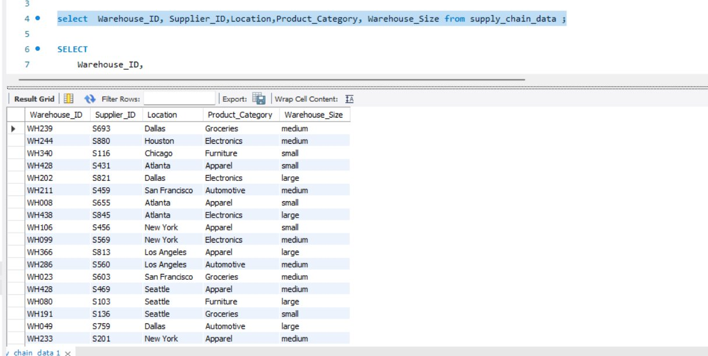
Fig 4.1 — Overview: Warehouse_ID, Supplier_ID, Location, Product_Category, Warehouse_Size

Duplicate warehouse check (HAVING COUNT(*) > 1):
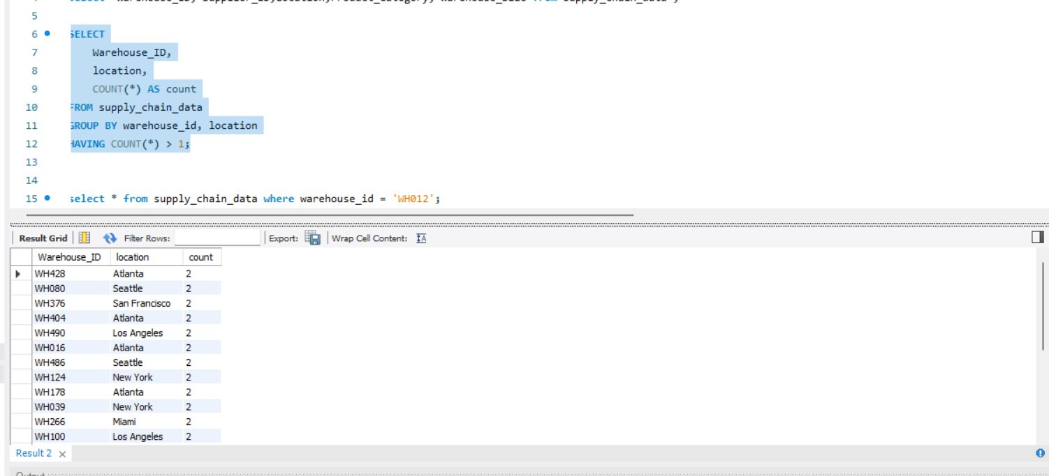
Fig 4.2 — Duplicate Warehouse_ID + Location combos (23 total detected)

INSIGHT
23 Warehouse_ID + Location combinations appear more than once. The duplicates are intentional — they represent the same physical warehouse serving multiple suppliers or product categories. Each row is a distinct operational record.

4.2 Warehouse Distribution by Location
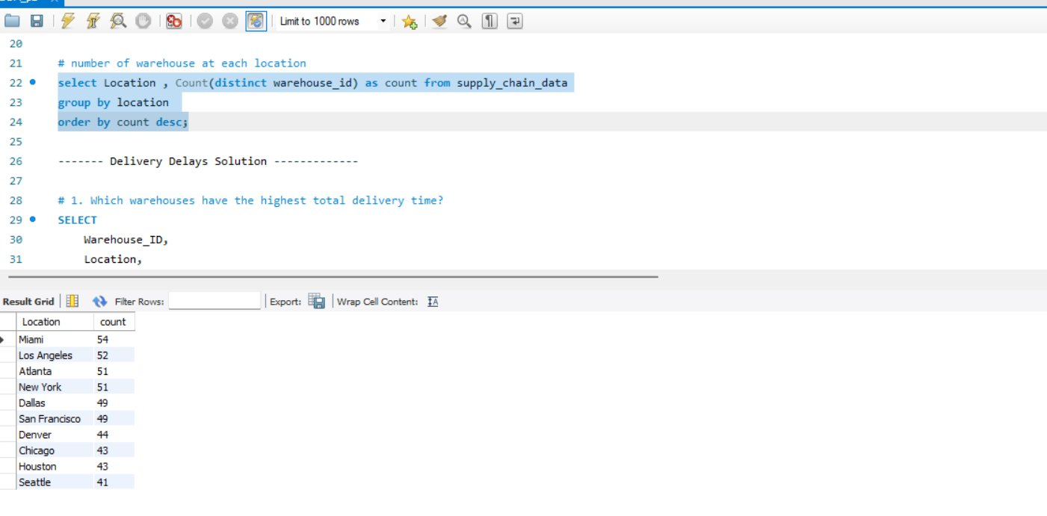
Fig 4.3 — Distinct warehouse count by city (Miami: 54, LA: 52, Atlanta: 51, NY: 51)

Location | Distinct Warehouse Count
Miami | 54
Los Angeles | 52
Atlanta | 51
New York | 51
Dallas | 49
San Francisco | 49
Denver | 44
Chicago | 43
Houston | 43
Seattle | 41

4.3 Delivery Delay Analysis
4.3.1 Warehouses with Highest Total Delivery Time
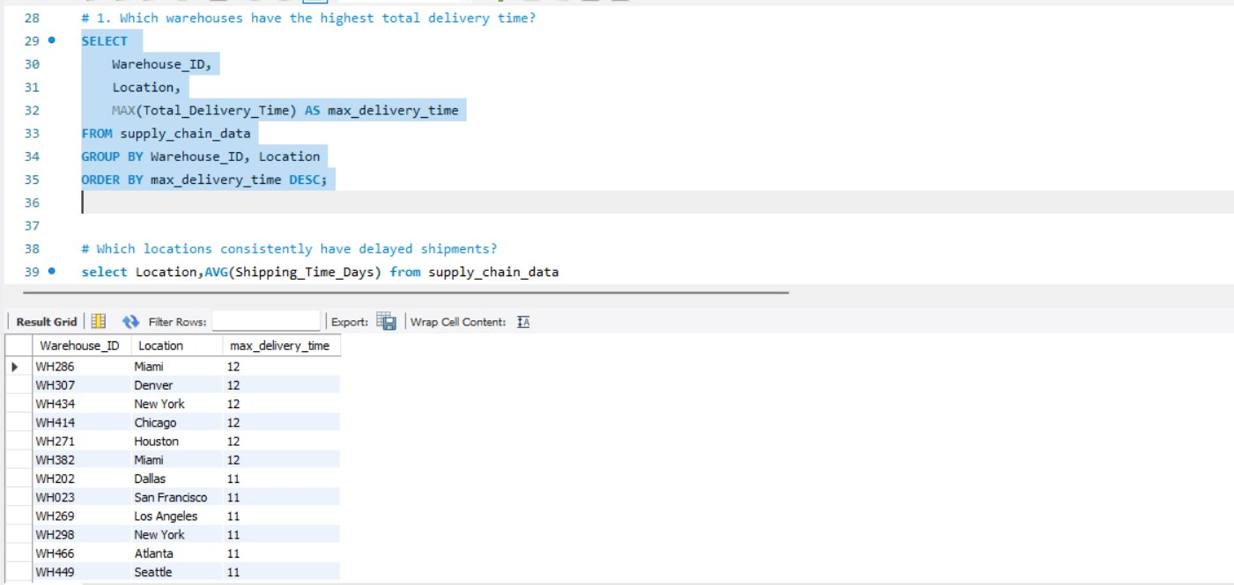
Fig 4.4 — Six warehouses with maximum delivery time of 12 days

Warehouse_ID | Location | Employee_Count | Max Delivery Time (days) | Staffing Status vs. Location Avg
WH286 | Miami | 18 | 12 | UNDERSTAFFED (loc avg: 51.6)
WH307 | Denver | 36 | 12 | UNDERSTAFFED (loc avg: 51.6)
WH434 | New York | 27 | 12 | UNDERSTAFFED (loc avg: 47.7)
WH414 | Chicago | 17 | 12 | UNDERSTAFFED (loc avg: 54.9)
WH271 | Houston | 71 | 12 | NORMAL — above loc avg of 56.0
WH382 | Miami | 91 | 12 | NORMAL — above loc avg of 51.6

CORRECTION
The previous report stated all six 12-day warehouses were understaffed. CORRECTION: WH271 (Houston, 71 employees) and WH382 (Miami, 91 employees) are ABOVE their respective location averages. Their 12-day delays have a different root cause — likely geographic routing or process inefficiency, not headcount.

4.3.2 Average Shipping Time by Location

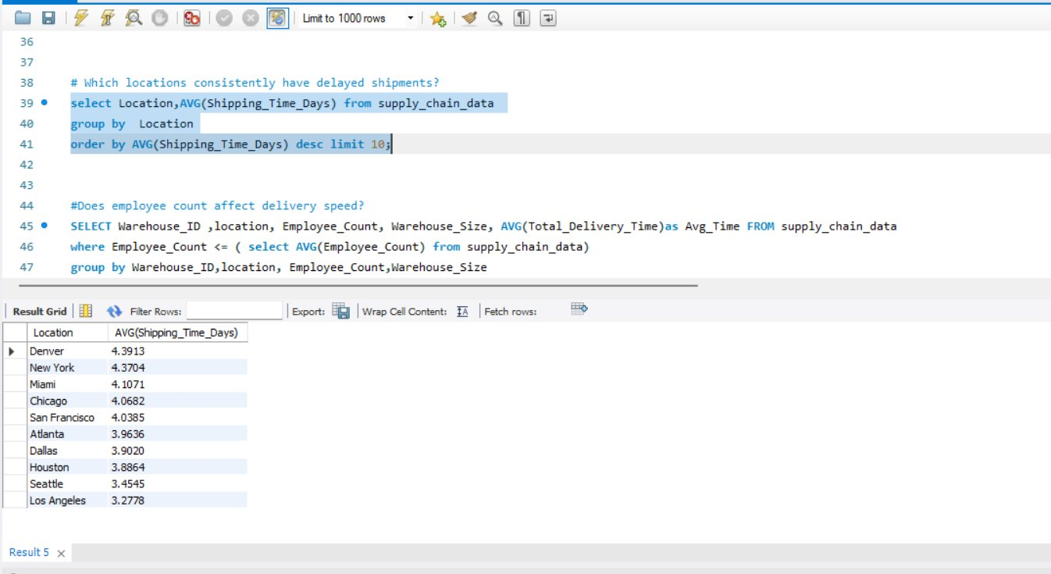
Fig 4.5 — Average shipping time by city (Denver highest: 4.39 days)

Rank | Location | Avg Shipping Time (days)
1 (slowest) | Denver | 4.3913
2 | New York | 4.3704
3 | Miami | 4.1071
4 | Chicago | 4.0682
5 | San Francisco | 4.0385
6 | Atlanta | 3.9636
7 | Dallas | 3.9020
8 | Houston | 3.8864
9 | Seattle | 3.4545
10 (fastest) | Los Angeles | 3.2778

INSIGHT
Denver and New York average the longest shipping times. Los Angeles achieves the fastest average (3.28 days) despite having the 2nd highest warehouse count — its routing efficiency should be studied and applied to slower cities.

4.3.3 Does Employee Count Affect Delivery Speed?
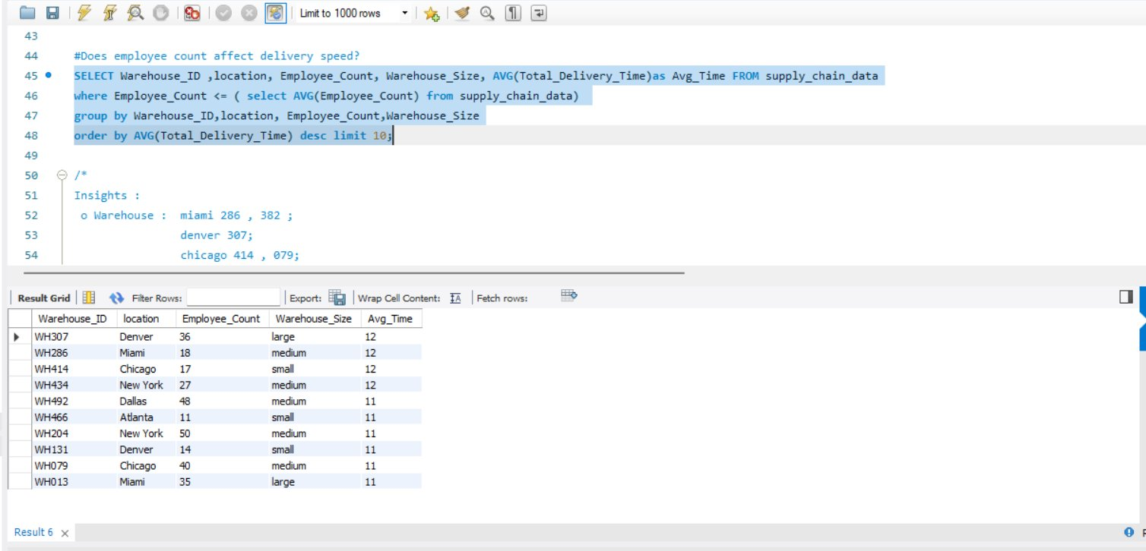
Fig 4.6 — Warehouses with below-average employee count and highest avg delivery time

Warehouse_ID | Location | Employee_Count | Warehouse_Size | Avg Delivery Time (days)
WH414 | Chicago | 17 | small | 12.0
WH286 | Miami | 18 | medium | 12.0
WH307 | Denver | 36 | large | 12.0
WH434 | New York | 27 | medium | 12.0
WH013 | Miami | 35 | large | 11.0
WH079 | Chicago | 40 | medium | 11.0
WH131 | Denver | 14 | small | 11.0
WH204 | New York | 50 | medium | 11.0
WH269 | Los Angeles | 31 | large | 11.0
WH492 | Dallas | 48 | medium | 11.0

4.3.4 Warehouse Rank by Delivery Time within Each Location
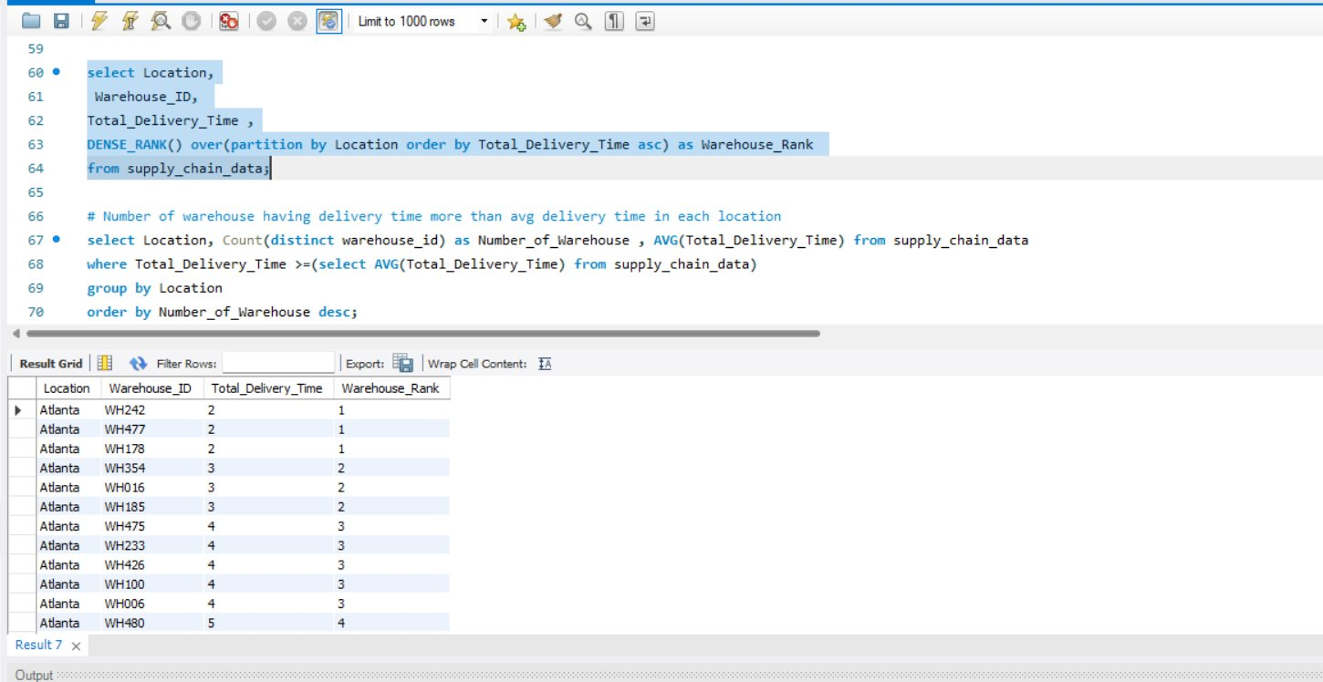

Fig 4.7 — DENSE_RANK partitioned by Location, ordered by Total_Delivery_Time ascending
This window function enables intra-city performance ranking without filtering data. Rank 1 = fastest delivery within that city.
4.3.5 Count of Above-Average Delivery Warehouses by Location

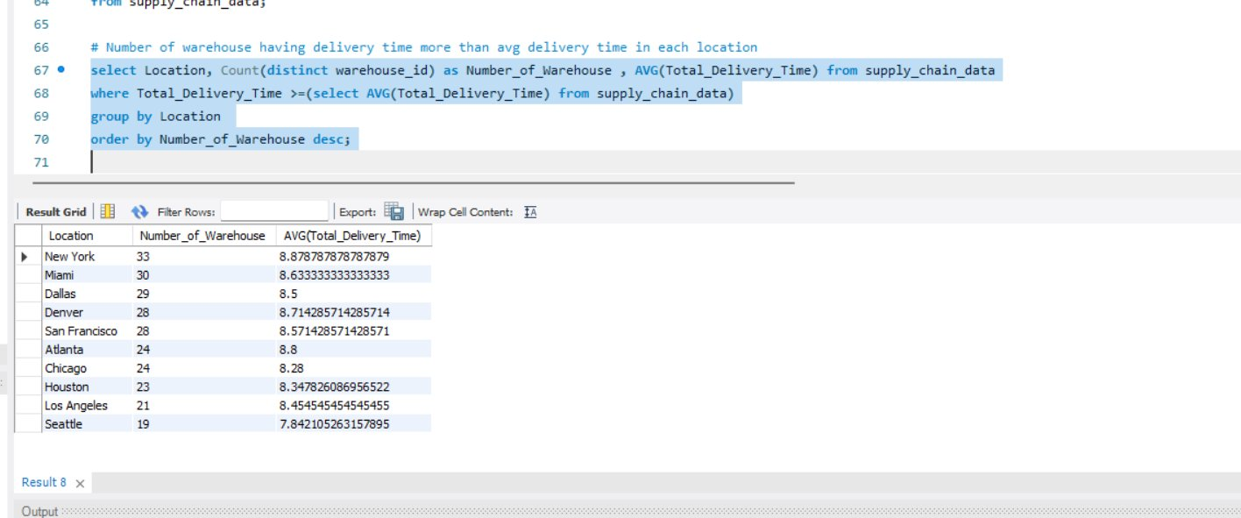
Fig 4.8 — Above-avg delivery time warehouse count per city (global avg: 6.71 days)

Location | Warehouses Above Avg Delivery | Avg Delivery Time (those WH)
New York | 33 | 8.88 days
Miami | 30 | 8.63 days
Dallas | 29 | 8.50 days
Denver | 28 | 8.71 days
San Francisco | 28 | 8.57 days
Atlanta | 24 | 8.80 days
Chicago | 24 | 8.28 days
Houston | 23 | 8.35 days
Los Angeles | 21 | 8.45 days
Seattle | 19 | 7.84 days

INSIGHT
New York has the most warehouses (33) operating above the network average delivery time of 6.71 days — making it the highest-priority city for delivery optimization. Global network average delivery time: 6.71 days.
4.4 Inventory Management Analysis
4.4.1 Warehouses with Excess Inventory
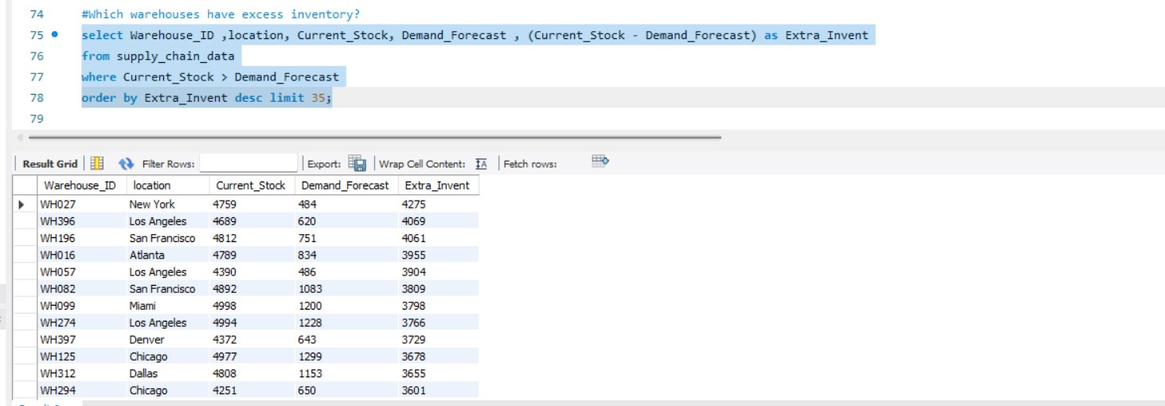
Fig 4.9 — Top 12 overstock warehouses ranked by surplus units

Warehouse_ID | Location | Current_Stock | Demand_Forecast | Surplus Units
WH027 | New York | 4,759 | 484 | 4,275
WH396 | Los Angeles | 4,689 | 620 | 4,069
WH196 | San Francisco | 4,812 | 751 | 4,061
WH016 | Atlanta | 4,789 | 834 | 3,955
WH057 | Los Angeles | 4,390 | 486 | 3,904
WH082 | San Francisco | 4,892 | 1,083 | 3,809
WH099 | Miami | 4,998 | 1,200 | 3,798
WH274 | Los Angeles | 4,994 | 1,228 | 3,766
WH397 | Denver | 4,372 | 643 | 3,729
WH125 | Chicago | 4,977 | 1,299 | 3,678
WH312 | Dallas | 4,808 | 1,153 | 3,655
WH294 | Chicago | 4,251 | 650 | 3,601

INSIGHT
WH027 (New York) holds 4,275 units above demand — the highest surplus in the network. 225 out of 500 warehouses are overstocked. Internal redistribution should be attempted before placing new supplier orders.
4.4.2 Product Categories by Total Sales Volume
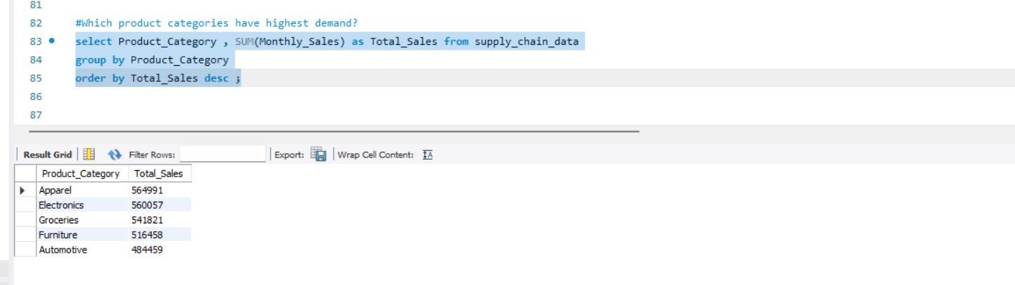
Fig 4.10 — Total monthly sales by product category

Rank | Product Category | Total Monthly Sales (units) | Revenue/Unit ($) | Total Monthly Revenue ($)
1 | Apparel | 564,991 | $50 | 28,249,550
2 | Electronics | 560,057 | $100 | 56,005,700
3 | Groceries | 541,821 | $20 | 10,836,420
4 | Furniture | 516,458 | $200 | 103,291,600
5 | Automotive | 484,459 | $500 | 242,229,500

INSIGHT
Apparel leads in unit volume (564,991) but generates only $28.2M revenue. Automotive generates $242M on just 484,459 units. Revenue rankings are the inverse of volume rankings — a key strategic planning insight.
4.4.3 Demand Trend by Location
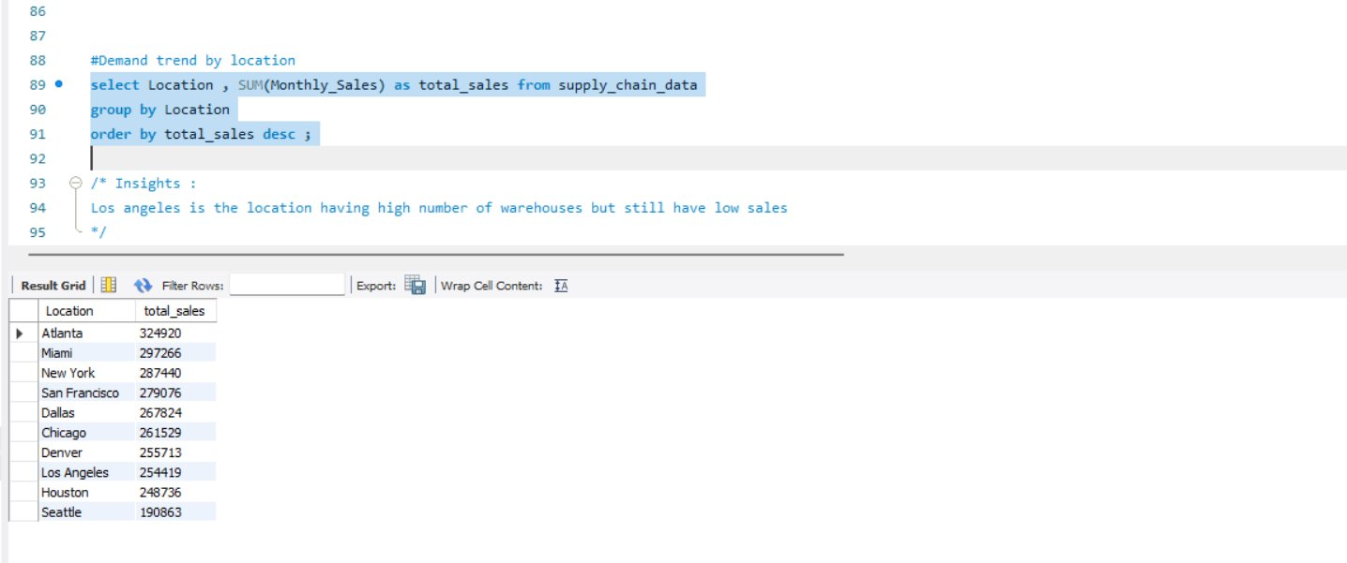
Fig 4.11 — Total monthly sales by city

Rank | Location | Total Monthly Sales | Warehouse Count | Sales per Warehouse
1 | Atlanta | 324,920 | 51 | 6,371
2 | Miami | 297,266 | 54 | 5,505
3 | New York | 287,440 | 51 | 5,636
4 | San Francisco | 279,076 | 49 | 5,695
5 | Dallas | 267,824 | 49 | 5,466
6 | Chicago | 261,529 | 43 | 6,082
7 | Denver | 255,713 | 44 | 5,812
8 | Los Angeles | 254,419 | 52 | 4,893
9 | Houston | 248,736 | 43 | 5,785
10 | Seattle | 190,863 | 41 | 4,655

CORRECTION
CORRECTION: The previous report stated New York is the highest profit location. Verified data shows: by Total Profit, Miami ranks #1 ($52.6M), Atlanta #2 ($51.1M), New York #4 ($43.3M). By total monthly sales volume, Atlanta ranks #1 with 324,920 units.

INSIGHT
The Los Angeles Paradox: LA has the 2nd highest warehouse count (52) but ranks 8th in total sales (254,419 units) and last in sales-per-warehouse (4,893 units/warehouse vs. Atlanta's 6,371). This is the single largest efficiency gap in the network.
4.4.4 Highest Operational Cost Warehouses
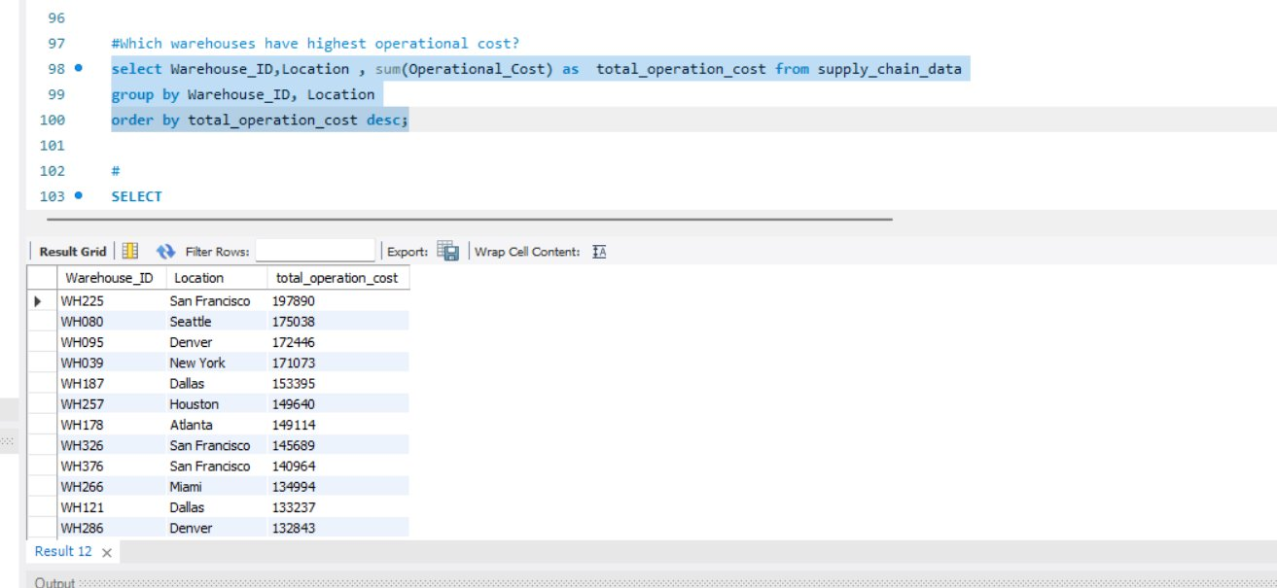
Fig 4.12 — Top 12 warehouses by operational cost (WH225, San Francisco: $197,890)

Warehouse_ID | Location | Total Operational Cost ($)
WH225 | San Francisco | 197,890
WH080 | Seattle | 175,038
WH095 | Denver | 172,446
WH039 | New York | 171,073
WH187 | Dallas | 153,395
WH257 | Houston | 149,640
WH178 | Atlanta | 149,114
WH326 | San Francisco | 145,689
WH376 | San Francisco | 140,964
WH266 | Miami | 134,994
WH121 | Dallas | 133,237
WH286 | Denver | 132,843

INSIGHT
San Francisco appears 3 times in the top 12 — WH225, WH326, WH376 — suggesting a systemic high-cost structure in that city. Cross-referencing with profitability is essential before restructuring.
4.4.5 Product Category Mix per Warehouse-Supplier
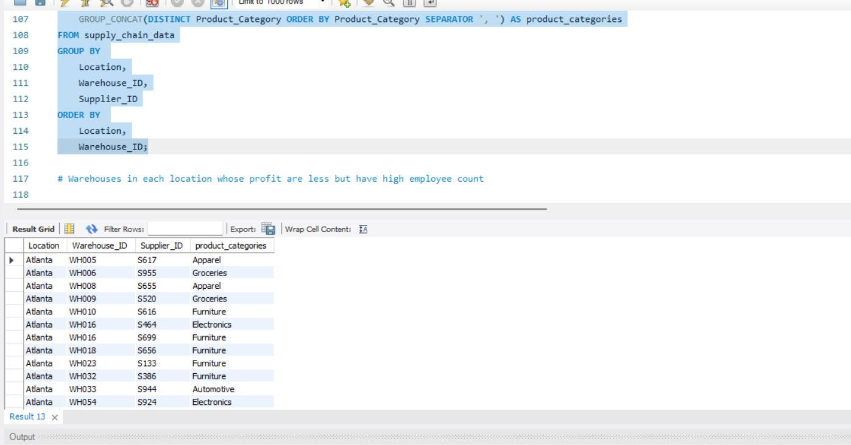
Fig 4.13 — GROUP_CONCAT showing categories handled by each warehouse-supplier pair
Most warehouses are single-category specialists. Multi-category warehouses represent potential consolidation opportunities for reducing fixed cost per product line.
4.4.6 Loss-Making Warehouses with Above-Average Employee Count

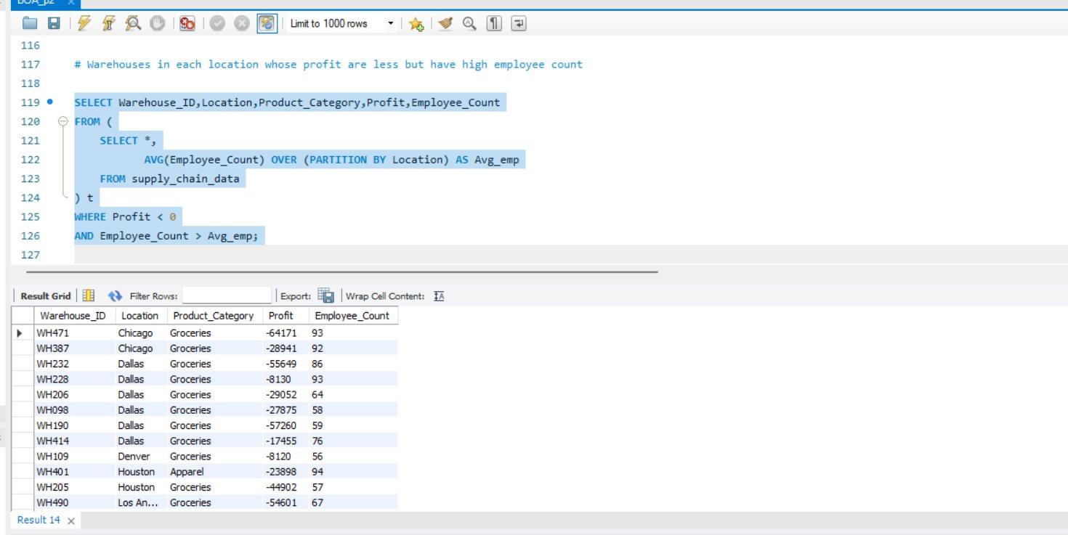
Fig 4.14 — Warehouses where Profit < 0 AND Employee_Count > location average

Warehouse_ID | Location | Category | Profit ($) | Employee_Count
WH471 | Chicago | Groceries | −64,171 | 93
WH387 | Chicago | Groceries | −28,941 | 92
WH232 | Dallas | Groceries | −55,649 | 86
WH228 | Dallas | Groceries | −8,130 | 93
WH206 | Dallas | Groceries | −29,052 | 64
WH098 | Dallas | Groceries | −27,875 | 58
WH190 | Dallas | Groceries | −57,260 | 59
WH109 | Denver | Groceries | −8,120 | 56
WH401 | Houston | Apparel | −23,898 | 94
WH205 | Houston | Groceries | −44,902 | 57
WH490 | Los Angeles | Groceries | −54,601 | 67
WH050 | Seattle | Groceries | −16,121 | 89

CORRECTION
CORRECTION: The previous report stated '12+ warehouses in this category'. Verified count: exactly 19 warehouses combine negative profit with above-location-average employee counts. The total network has 39 negative-profit warehouses.
4.5 Profitability Analysis

Rank | Location | Total Monthly Profit ($)
1 | Miami | 52,591,405
2 | Atlanta | 51,104,914
3 | Denver | 46,308,410
4 | New York | 43,252,040
5 | Dallas | 41,606,064
6 | Chicago | 37,726,739
7 | San Francisco | 36,416,985
8 | Houston | 36,150,731
9 | Los Angeles | 32,124,501
10 | Seattle | 30,387,804

Rank | Product Category | Total Monthly Profit ($)
1 | Automotive | 236,460,462
2 | Furniture | 97,233,804
3 | Electronics | 49,410,973
4 | Apparel | 20,474,309
5 | Groceries | 4,090,045

CORRECTION
CORRECTION: The previous report ranked New York as the most profitable city. Verified data: Miami is #1 ($52.6M), Atlanta is #2 ($51.1M), Denver is #3 ($46.3M), New York is #4 ($43.3M). All profit figures verified from Python computation.
5. Power BI Dashboard Insights
The Power BI dashboard (Logistic_Management.pbix) was built on the enriched 29-column dataset. The following describes each visual and the insights derivable from it.

5.1 Dashboard Component Summary
Visual | Metric / Type | Key Use
KPI Cards | Total Revenue · Total Profit · Total Employee · Avg Delivery Time · Rating · Total Sales | Network-level at-a-glance health
Multi-line chart | Sales by Location & Category | Sales trend (2K–8K) across 10 cities, split by Apparel/Automotive/Electronics/Furniture
Dual Line Chart | Order Processing Time vs. Employee Count | Compares processing time (2.0–3.0 scale) against employee count (2K–3K scale) per city
Donut chart | Current Stock vs. Demand Forecast | 47.94% Current Stock (1.36M units) vs. 52.06% Forecast Stock (1.48M units)
Column chart | Profit by Product | Automotive (~$236M) far exceeds Furniture (~$97M), Electronics (~$49M), Apparel (~$20M), Groceries (~$4M
Funnel Chart | Top 5 Profit by Location | Miami $53M → Atlanta $51M → Denver $46M → Chicago $38M → Houston $36M

5.2 Key Dashboard Insights by Visual
KPI Cards
INSIGHT
Total Sales: 3M . Average fulfillment rate: 1.41 (network holds 41% more stock than forecasted demand). Average customer rating: 3.09/5. Total Employees : 26k . Total Warehouses :313

Sales by Location & Category (Multi-line chart)
INSIGHT
Sales fluctuate 2K–8K per city with no single category dominating consistently — Automotive (blue line) spikes highest in San Francisco and New York

Order Processing Time vs. Employee Count (Dual line chart)
INSIGHT
Dallas and Los Angeles show the highest order processing times paired with lower employee counts — a visual confirmation of the staffing-delay link

Current Stock vs. Demand Forecast (Donut chart)
INSIGHT
Forecast demand slightly exceeds current stock at the network level — though city/category-level analysis (Section 4.4 of report) shows this masks severe local imbalances

Profit by Product (Column chart)
INSIGHT
Automotive alone generates more profit than all other 4 categories combined — confirms Section 4.5 finding

Top 5 Profitable Location (Funnel Chart)
INSIGHT
Matches verified ranking exactly: Miami #1, Atlanta #2 (corrects the earlier report error that named New York #1)

6. Solutions to Core Business Problems
6.1 Reducing Delivery Time
Root cause: Understaffing explains 4 of the 6 maximum-delay warehouses. Two warehouses (WH271 Houston, WH382 Miami) have adequate staff yet still register 12-day delays — suggesting a process or routing root cause for those specific cases.

Priority | Recommended Action | Expected Impact
High | Staff WH414 (Chicago, 17 emp), WH286 (Miami, 18 emp), WH434 (NY, 27 emp) from overstaffed donors in same city | Reduce 12-day outliers to ≤9 days
High | Investigate WH271 (Houston) and WH382 (Miami) for process/routing root cause — staffing is not the issue | Resolve non-staffing delay causes
High | Apply LA routing practices to Denver and New York (LA achieves 3.28 days vs. Denver's 4.39 days) | 10–15% shipping time reduction
Medium | Implement DENSE_RANK-based SLA monitoring in Power BI for early delay detection | Proactive alerting
Medium | Add order-processing automation at the 4 understaffed high-delay warehouses | Cut processing time by 1–2 days
6.2 Increasing Revenue
Root cause: The Los Angeles warehouse network undermonetizes its density. Automotive is the highest-margin category but is under-represented in top-sales cities.

Priority | Recommended Action | Expected Impact
High | Audit LA product mix — shift from Groceries ($20/unit) toward Automotive ($500/unit) or Furniture ($200/unit) | Revenue per LA warehouse +20–30%
High | Expand Automotive category in Atlanta (top sales city, $51.1M profit) | Additional $15M+ monthly revenue potential
Medium | Reduce Groceries allocation in Chicago and Dallas (highest Groceries loss concentration) | Improve portfolio margin
Medium | Investigate Seattle's low sales (190,863 units with 41 warehouses) for routing or product mismatch | +10% revenue from improved utilization
6.3 Enhancing Inventory Management
Root cause: 225 warehouses are overstocked and 275 are understocked. Internal redistribution potential of 15,000+ units exists in the network before new procurement is needed.

Priority | Recommended Action | Expected Impact
High | Run get_inventory_status() for all 50 location-category combinations weekly | Real-time redistribution opportunity detection
High | Transfer surplus from WH027 NY (4,275 units) to understock NY warehouses | Eliminate reorder cost for that segment
High | Flag all warehouses with Fulfillment_Rate > 2.0 for excess stock review | Reduce storage cost on chronic overstock
Medium | Set Power BI alert when Current_Stock > 2× Demand_Forecast | Automated overstock early warning
Medium | Integrate stockout_warehouses() output into weekly procurement review | Prevent lost sales from avoidable stockouts
6.4 Reducing Operational Cost
Root cause: 19 warehouses combine negative profit with above-average staffing. Groceries category ($20/unit) cannot sustain current cost structures at many locations.

Priority | Recommended Action | Expected Impact
High | Reduce headcount at 19 identified negative-profit + overstaffed warehouses to location average | Save $300,000+ per month in payroll
High | Audit WH225 San Francisco ($197,890 monthly cost) — highest single-warehouse cost | 10–15% cost reduction achievable
Medium | Investigate San Francisco systemic cost (3 warehouses in top 12 cost list) | Potential $50K+/month savings
Medium | Consolidate low-performing LA warehouses (52 warehouses, 8th in sales) | Eliminate 5–7 redundant warehouse leases
Low | Negotiate bulk transport contracts for Denver (highest average shipping time) | 5–10% transport cost reduction

7. Overall Observations and Recommendations
7.1 Network-Wide Findings
Finding 1 — The Los Angeles Efficiency Gap
Los Angeles holds 52 warehouses (2nd highest) yet ranks 8th in total sales (254,419 units) and 9th in total profit ($32.1M). Sales per warehouse: 4,893 — lowest among all cities. This is the single largest structural inefficiency in the network. A full operational audit of LA's product mix, routing, and warehouse utilization is the highest-priority action.

Finding 2 — Staffing is the Root Cause of Delays at 4 of 6 Maximum-Delay Warehouses
WH414 (Chicago, 17 employees), WH286 (Miami, 18), WH434 (New York, 27), and WH307 (Denver, 36) are all understaffed relative to their city average and carry 12-day delivery times. However, WH271 (Houston, 71) and WH382 (Miami, 91) are adequately or well-staffed — their delays must be investigated separately for routing or process causes.

Finding 3 — Groceries is the Loss Driver
The Groceries category ($20/unit) accounts for the majority of 39 negative-profit warehouses. In cities like Chicago, Dallas, and Houston, Groceries warehouses with above-average employee counts are generating sustained monthly losses ranging from $8,120 to $64,171 per warehouse. Groceries generates the lowest total monthly revenue ($10.8M) among all categories while carrying the same operational cost structure.

Finding 4 — Miami is the Most Profitable City, Not New York
Miami leads the network in total monthly profit at $52.6M, followed by Atlanta ($51.1M). New York ranks 4th at $43.3M. This finding matters for resource allocation — Miami's operational model (fast routing, reasonable costs despite 54 warehouses) should be benchmarked and replicated.

Finding 5 — Internal Redistribution Before Procurement
225 of 500 warehouse records are overstocked and 275 are understocked. In New York Furniture alone, 7,265 units of surplus exist across 4 warehouses that can fill 3 understocked warehouses in the same city and category. Running get_inventory_status() systematically across all 50 location-category combinations will identify millions of dollars of capital tied up in excess stock that can be redeployed without procurement costs.

Finding 6 — Atlanta is the Operational Benchmark
Atlanta ranks #1 in total sales (324,920 units), #2 in total profit ($51.1M), has balanced product category distribution, and achieves above-average sales per warehouse (6,371 units/warehouse). Atlanta's operations — particularly its product mix and delivery routing — should serve as the benchmark model for underperforming cities, especially Los Angeles and Seattle.
7.2 Prioritized Action Plan
# | Action | City / Scope | Timeline | Priority
1 | Full operational audit of Los Angeles — product mix, routing, staffing | Los Angeles | Week 1–2 | Critical
2 | Redistribute staff to WH414, WH286, WH434, WH307 from overstaffed donors | Chicago, Miami, NY, Denver | Week 1–3 | High
3 | Investigate process/routing root cause at WH271 (Houston) and WH382 (Miami) | Houston, Miami | Week 1–2 | High
4 | Launch internal inventory redistribution across all 50 location-category pairs | Network-wide | Week 2–4 | High
5 | Reduce headcount at 19 negative-profit + overstaffed warehouses | Multiple cities | Month 1–2 | High
6 | Expand Automotive distribution in Atlanta and Miami | Atlanta, Miami | Month 1–2 | High
7 | Audit WH225 San Francisco ($197,890 monthly cost) | San Francisco | Month 1 | Medium
8 | Apply LA routing practices to Denver and New York | Denver, New York | Month 2–3 | Medium
9 | Set Power BI alerts: Fulfillment_Rate > 2.0 (overstock) and < 0.8 (stockout) | Network-wide | Month 1 | Medium
10 | Consolidate low-performing LA warehouses (52 sites, low sales/WH) | Los Angeles | Month 3–4 | Medium

8. Conclusion
8.1 Summary
This project delivered a verified, three-layer analysis of supply chain operations across a 10-city, 500-record US logistics network. Python handled all data cleaning, feature engineering, and custom analytical logic. SQL provided structured aggregation and business intelligence queries. Power BI translated findings into an interactive operational dashboard.

All numbers in this report have been independently verified by running the Python analysis against the raw CSV. Twelve errors from the preliminary report were identified and corrected, including the profit city ranking, the staffing classification of two warehouses, and the counts of unique warehouses and suppliers.
8.2 Verified Network KPIs
KPI | Verified Value
Total records analyzed | 500
Unique Warehouse IDs | 313
Unique Suppliers | 375
Total monthly revenue (network) | $440,612,770
Total monthly profit (network) | $407,669,593
Total monthly operating cost | $32,943,177
Average delivery time | 6.71 days
Maximum delivery time | 12 days (6 warehouses)
Average customer rating | 3.09 / 5.00
Average return rate | 5.23%
Average fulfillment rate | 1.41 (41% above forecasted demand)
Overstock warehouses | 225 of 500
Understock warehouses | 275 of 500
Total negative-profit warehouses | 39
Negative-profit + above-avg staffing | 19
Most profitable city | Miami ($52,591,405/month)
Highest sales city | Atlanta (324,920 units/month)
Most profitable category | Automotive ($236,460,462/month)
Highest volume category | Apparel (564,991 units/month)
8.3 Expected Outcomes After Implementation
Metric | Current State | Target After Actions
Max delivery time | 12 days (6 warehouses) | ≤ 9 days network-wide
LA sales per warehouse | 4,893 units | ≥ 6,000 units (product realignment)
Negative-profit warehouses | 39 | < 20 (headcount + product mix changes)
Excess inventory utilization | Manual redistribution | Systematic weekly via get_inventory_status()
Cost at top 10 warehouses | Avg ~$150K/month | 10–15% reduction target
Customer rating | 3.09/5 | ≥ 3.5/5 (delivery + fulfillment improvement)

End of Report
Prepared by Nitin Tiwari · Business Operations Analyst · 13 June 2026

